# Software Project Management Plan

## Problem Definition

### Name of this Capstone Project

### Problem Abstract

### Project Overview

#### Current Situation

#### The Proposed System

Based on current issues, combined with researches traffic system of HCM city and the cutting edge technologies related. We came up with a proposal of a system which can help participants traffic easily search for route to quickly and intelligently by the suggestions, notices. In addition to support on mobile devices, the system supports both smart watches.

Our system includes three main subsystems: an online website for company’s staffs, a mobile application as well as watch application for Participants traffic.

##### Website

Website provide following features:

* For staffs:
  + - Staff edit information for bus route and bus timetable.
    - Notify new update data from server to staff
    - Check new data periodically at 0 AM each day

Beside above, website system also provides an API interface for mobile, wear applications to retrieve data

##### Mobile Application

This mobile application is used by participants traffic. This application do followings:

* Find bus route through from two points to four points.
* Find bus route through from two points to four points with optimize.
* Find motorcycle route through from two points to four points.
* Find motorcycle route through from two points to four points with optimize.

##### Wear Application

* Bus:

App will notify for user when bus  nears the station that user should to leave.

* Motorcycle:

App will notify when user has to turn route.

* Map:

Show current user location on map with route user should to go (including bus or motorbike).

#### Boundaries of the System

#### Development Environment

##### Hardware requirement

* For continuous integrating server:

|  |  |  |
| --- | --- | --- |
| Hardware | Minimum Requirements | Recommended |
| Internet Connection | 512Kbps | 8 Mbps |
| Operating System |  |  |
| Computer Processor | Intel® Core 2 Duo | Intel® Core(TM) i5 CPU , M 460 @ 2.53GHz |
| Computer Memory | 2GB RAM | 3GB or more |

Table 1 Hardware requirement for continuous integrating server

* For web development:

|  |  |  |
| --- | --- | --- |
| Hardware | Minimum Requirements | Recommended |
| Internet Connection | 512Kbps | 8 Mbps |
| Operating System | Window XP, Vista, 7, 8 | Window 7, 8 |
| Computer Processor | Intel® Core 2 Duo | Intel® Core(TM) i5 CPU , M 460 @ 2.53GHz |
| Computer Memory | 2GB RAM | 3GB or more |

Table 2 Hardware requirement for web development

* For mobile development:

|  |  |  |
| --- | --- | --- |
| Hardware | Minimum Requirements | Recommended |
| Internet Connection | Wi-Fi Connection 2MB | Wi-Fi Connection 12MB |
| Operating System | Android 4.0 | Android 5.0 |
| Hardware |  |  |
| Memory | 1 GB RAM | 2 GB or more |

Table 3 Hardware requirement for mobile development

* For wear development:

|  |  |  |
| --- | --- | --- |
| Hardware | Minimum Requirements | Recommended |
| Internet Connection |  |  |
| Operating System | Android 4.3 | Android 5.1 |
| Hardware |  |  |
| Memory | 512MB RAM | 1 GB or more |

Table 4 Hardware requirement for wear development

##### Software requirement

|  |  |
| --- | --- |
| Software | Name / Version |
| Operating system | Windows 7 or above |
| Environment | Java EE 6 |
| Modeling tool | StartUML |
| IDE | Intellij IDEA 14.1, Android Studio |
| DBMS | MySQL 5.6 |
| Source control | Source Tree 1.6.20.0 |
| Web browser | Chrome 42 or above |

Table 5 Software requirement

## Project organization

### Software Process Model

This project is developed under agile model. We choose this model because the following reasons:

* This project is performed in 4 months which can be consider a short. So functionality must developed rapidly and frequently demonstrated.
* Promotes teamwork and cross training.
* It help manager easy to manage project progress.

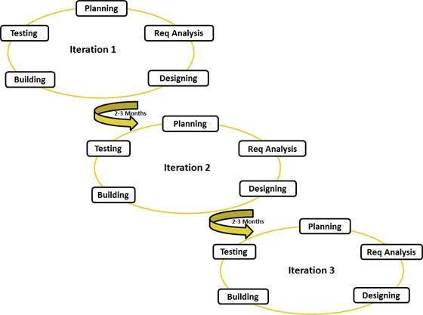

Figure 1 Agile model

More information about agile model:

http://www.tutorialspoint.com/sdlc/sdlc_agile_model.htm

### Roles and responsibilities

### Tools and Techniques

## Project Management Plan

### Task sheet

### All Meeting Minutes

## Coding Convention